

May 2018 – July 2018

**UNLV INTERNSHIP**

**Emergency response UAVs**

Matthieu Cambusier

***Tutor***

*Mr Venkatesan Muthukumar*

# Thanking :

I would like to thank first the UNLV which allow me to do my internship within the univerisity.

I am greatful to Mr Muthukumar who accepted to be my tutor and his good advices that helped me during my intern.

I also want to thank Mr Cho for his help while we were filling out the administrative papers for the UNLV.

# Abstract :

The purpose of this project is to detect someone screaming for help with a drone to rescue him.

To do this, we calibrated the drone with the pixhawk 4 so that it could fly properly. Then, we collected some data (voice, bullet, car, wind …) and created an algorithm to mix them and apply denoising on this.

# Table of contents

Thanking : 1

Abstract : 2

Table of contents 3

Introduction : 4

Material and tasks : 5

I. Equipment : 5

1. Quadcopter : 5

2. Pixhawk : 5

3. Digital voice recorder USB : 8

II. Tasks : 9

1. Quadcopter flight : 9

2. Collecting noise : 10

3. Code : 11

III. Conclusion : 16

IV. Annex : 17

1. Python code for the simulation : 17

Sources : 25

# Introduction :

As part of my engineering training, a minimum stay of 3 months abroad is required to obtain the diploma. This is why I choosed to do an internship of 3 months at the University of Nevada Las Vegas (UNLV).

My internship tooked place in the field of the aeronautic by working on a drone.

A drone is an unmanned "robotic" vehicle that can be remotely or autonomously controlled. Drones are used for many consumer, industrial and military [use cases and applications](http://px4.io/applications/) :

* Aerial photography/video
* Carrying cargo
* Racing
* Search
* Surveying

Nowadays, the security is very important and when someone is in danger, it is important to locate this person very quickly to rescue him/her so that he/she can be treat as quickly as possible.

To do that, the use of a drone is a good solution. The aim of this project is that a drone detect someone calling « Get help » despite the other sound around.

In a first part I will introduce the materials used for this project and how they work. The second part will be about all the technical and code made.

# Material and tasks :

## Equipment :

### Quadcopter :

The quadcopter was made by *Skyworks Aerial Systems*.

The quadcopter is a cheap kit and you have to assemble it. Fortunately for me, the dorne was already asssembled.

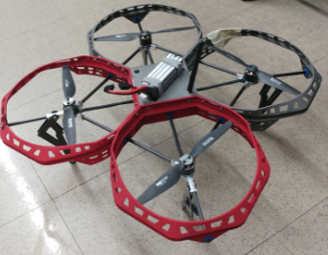 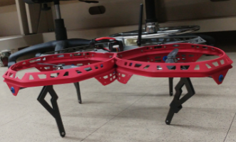

*Picture :Drone assembled*

To flight the drone you need to connect it with a Pixhawk.

### Pixhawk :

#### Presentation :

Pixhawk is an independent open-hardware project that aims to provide the standard for readily-available, hiqh-quality and low-cost autopilot hardware designs for the academic, hobby and developer communities. It features advanced processor and sensor technology from ST Microelectronics and a NuttX real-time operating system, delivering performance, flexibility, and reliability for controlling any autonomous vehicle.

Manufacturers have created many different boards, but in this project we worked with the « Pixhawk 4 ».

#### Pixhawk 4 :

Pixhawk 4 is an advanced autopilot designed and made in collaboration with Holybro and the PX4 team. PX4 all kinds of vehicles from racing and cargo drones through to ground vehicles and submersibles.

It is optimized to run PX4 version 1.7, suitable for academic and commercial developers.

It is based on the Pixhawk-project FMUv5 open hardware design and runs PX4 on the NuttX OS.

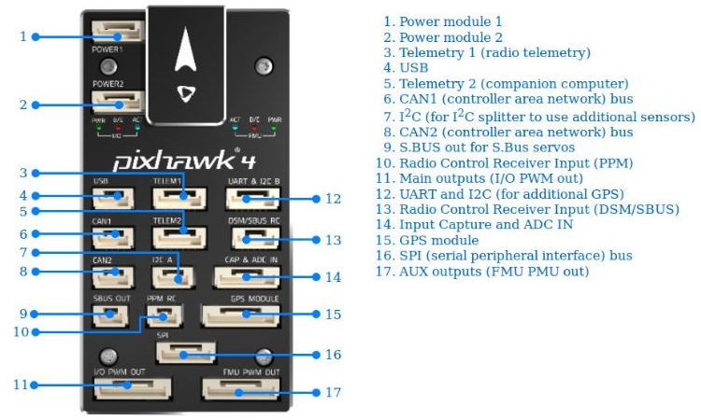

*Figure : Pixhawk connectors*

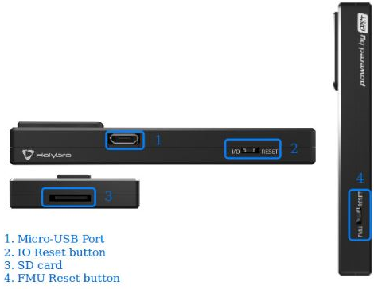

*Figure : Pixhawk connectors*

PX4 uses sensors to determine vehicle state (position/altitude, heading, speed, airspeed, orientation, rates of rotation in different directions, battery level, etc.). For the drone’s flight, I calibrated these sensors to flight the drone properly.

#### Hardware installation :

The following picture shows how to connect the different components to the pixhawk :

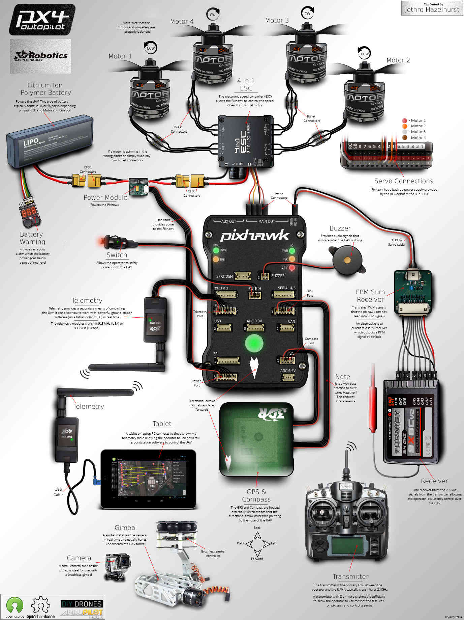

*Figure :Pixhawk connected to the other equipments*

### Digital voice recorder USB :

To record the data, we used an USB key that record the voice.

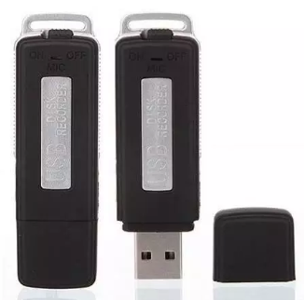

*Figure :USB key voice recorder*

Don’t forget to check if the battery is charged to use the microphone.

## Tasks :

### Quadcopter flight :

Once the drone calibration done, I did a flight with the drone. All the explications for the calibration of the drone and the drone’s flight are in the slides « tutorial_QGroundController ».

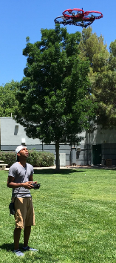

*Picture : Flight with the quadcopter*

### Collecting noise :

To collect the data, I scotched the USB key on the drone but I had to scotched near to the helix.

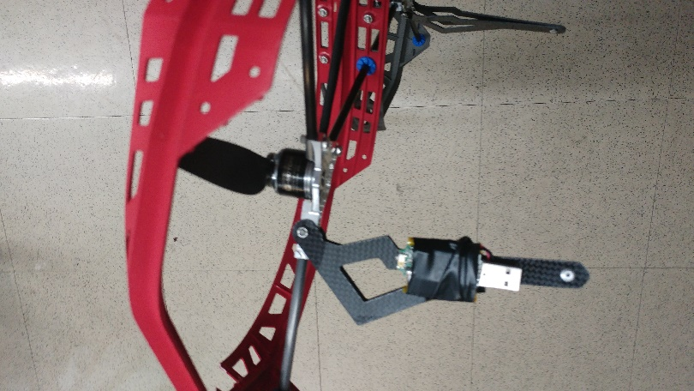 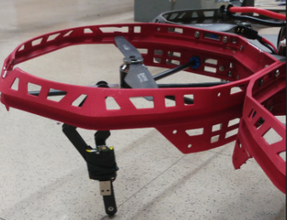

*Picture : USB key scotched to the drone*

For the recording, slide the button on « ON ». You will see a red light and after it will turn into a blue light. At this moment, this means that USB is recording.

### Code :

#### Simulation :

For the simulation, I have 4 classes :

* The controller, which control the drone.
* The GUI, it shows the drone flying.
* The quadcopter where the different equation of state are defined.
* The simulation, we can simulate one or more drone(s).

The code will be in the annex part.

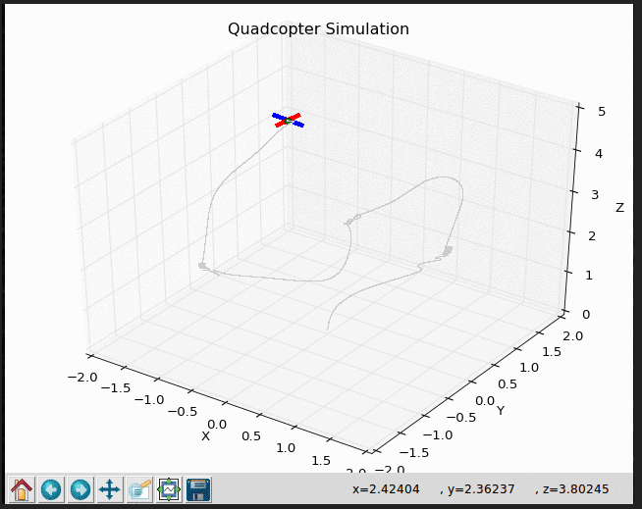 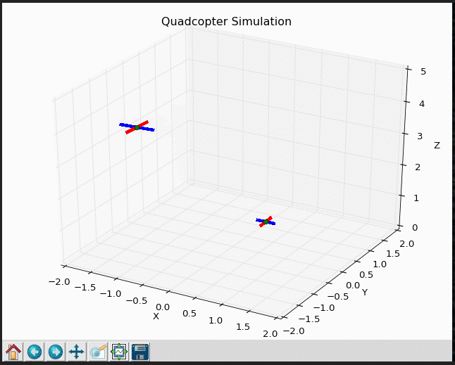

*Picture : Quadcopter(s) simulation*

#### Denoising algorithm :

##### Python :

Once the data recorded, I had to apply a denoising algortihm.

First, I did a Python code

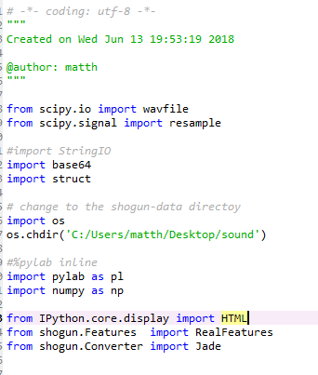

*Picture : Python code*

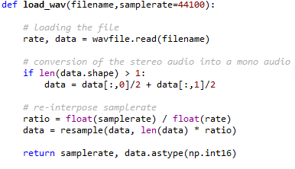

*Picture : Python code*

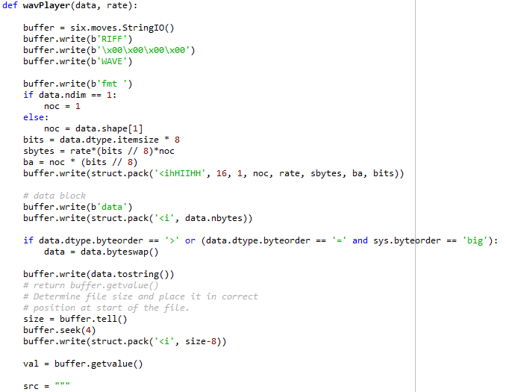

*Picture : Python code*

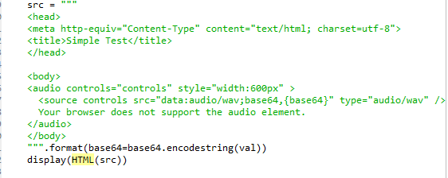

*Picture : Python code*

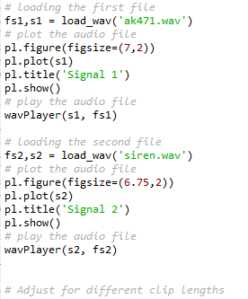

*Picture : Python code*

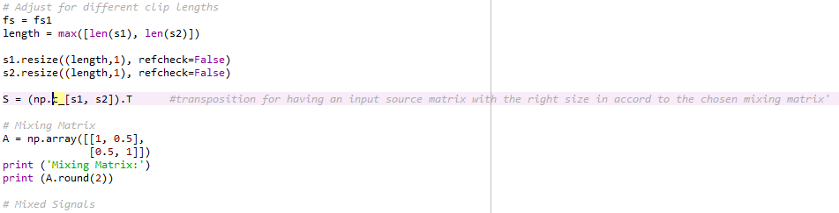

*Picture : Python code*

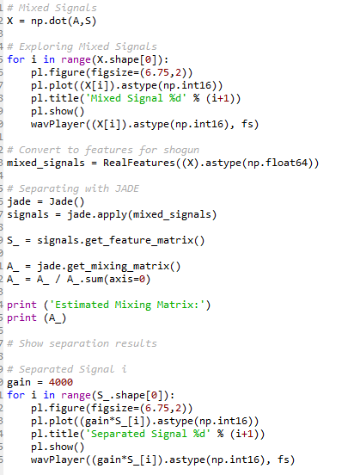

*Picture : Python code*

Unfortunately, the code doesn’t work because of the shogun module

## Conclusion :

During this internship, I learnt a lot about the drone (the operation, the theory …).

I also learned more about the embedded systems, the autonomous vehicle and how works the denoising.

This internship allow me to improve my skills in communication and to experience an other culture

## Annex :

### Python code for the simulation :

#### Controller :

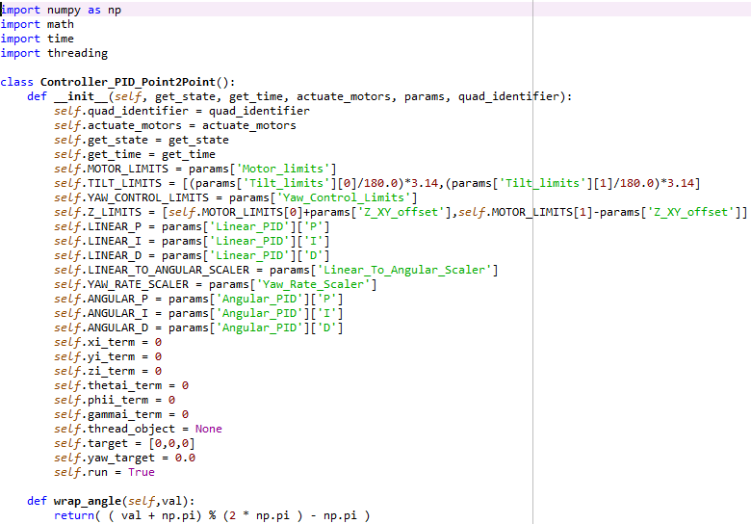

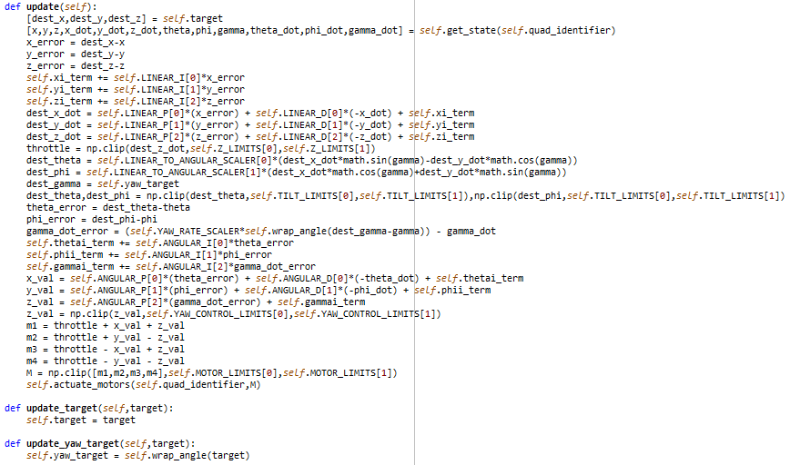

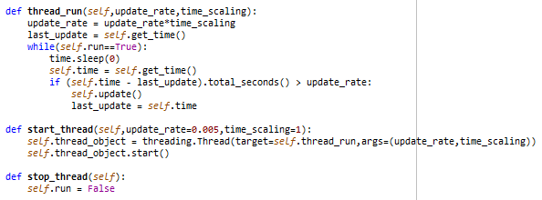

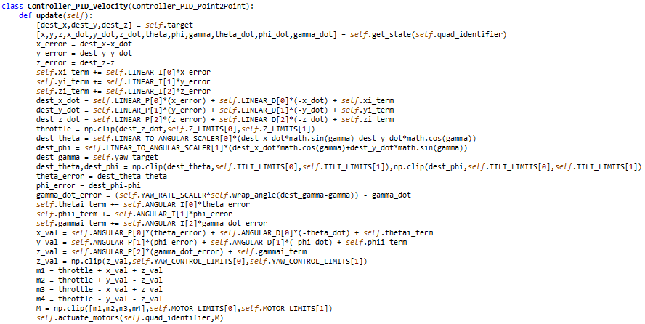

#### GUI :

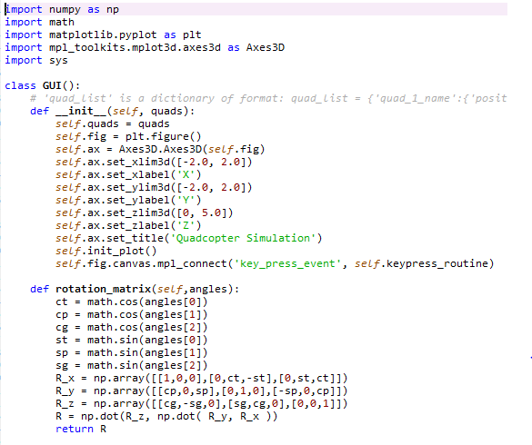

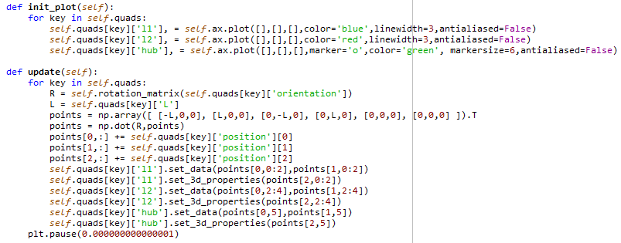

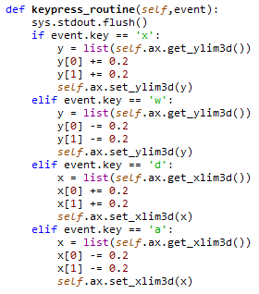

#### Quadcopter :

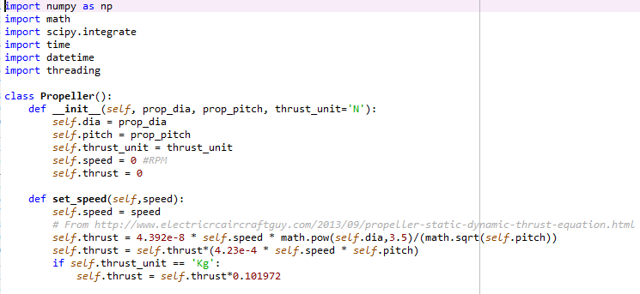

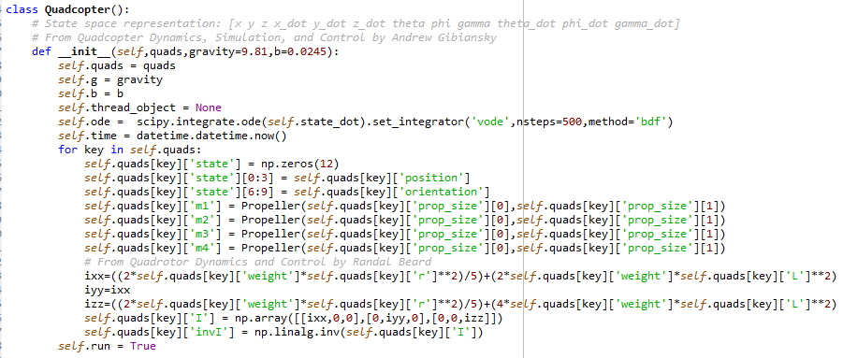

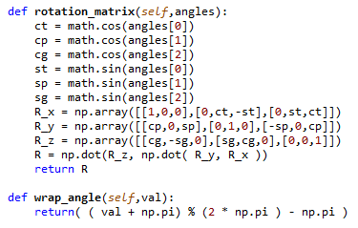

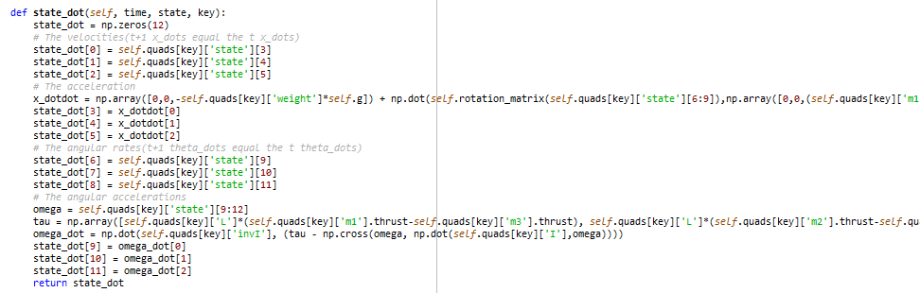

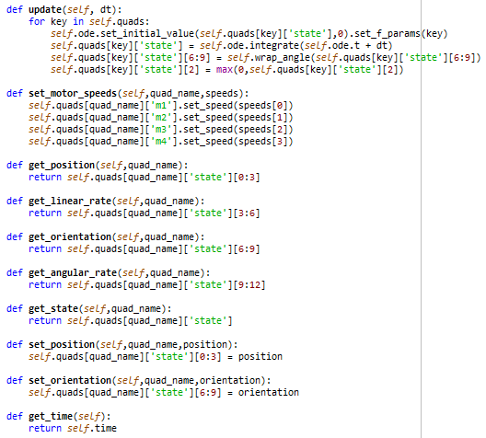

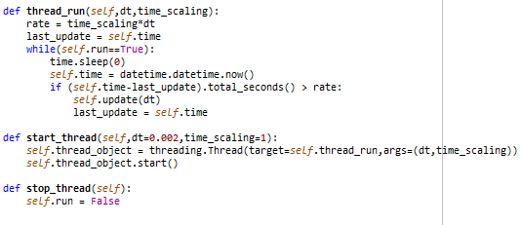

#### Simulation :

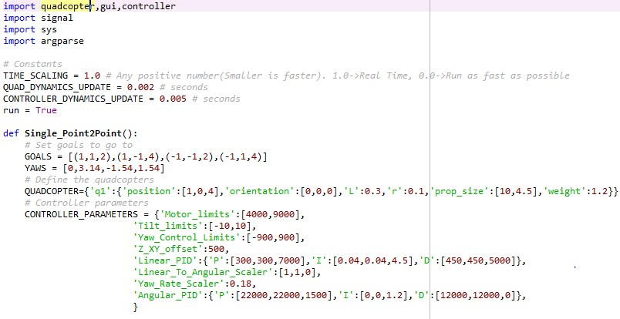

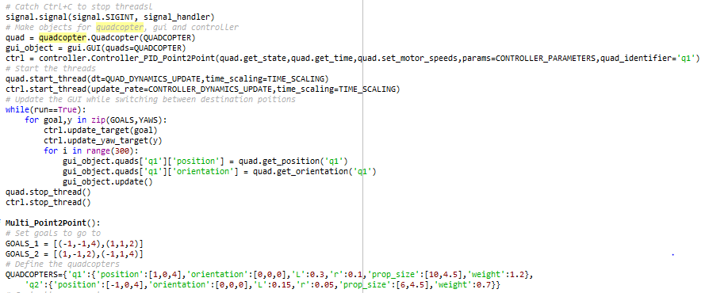

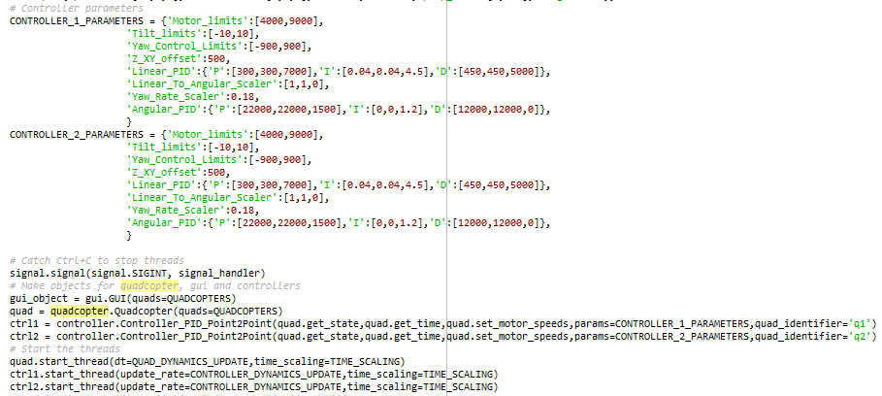

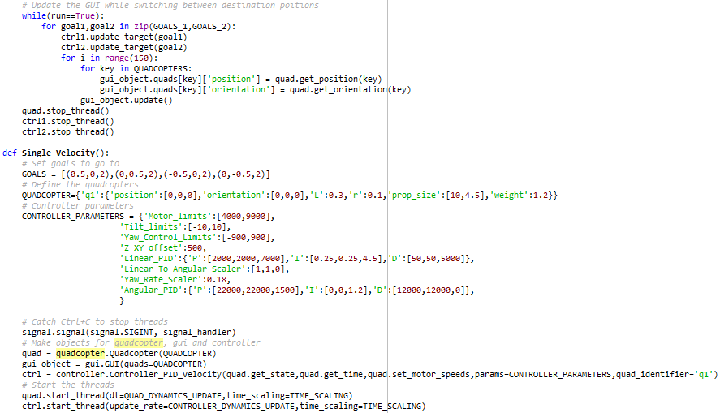

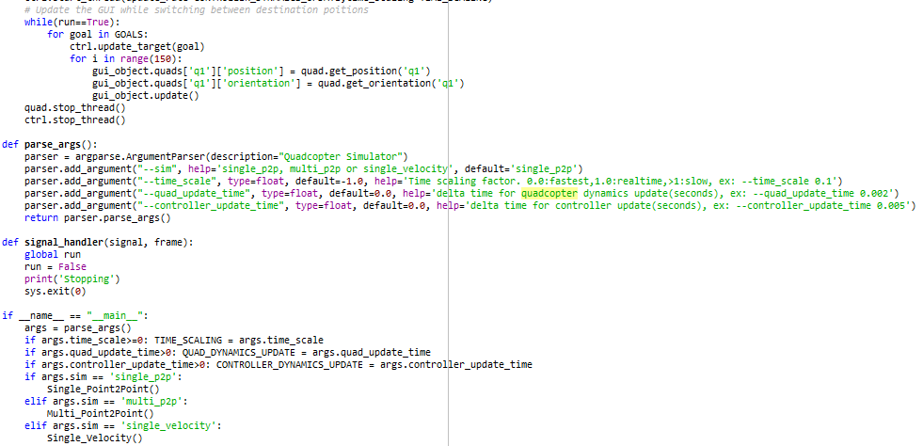

# Sources :

<https://github.com/abhijitmajumdar/Quadcopter_simulator>

<http://ardupilot.org/copter/docs/advanced-pixhawk-quadcopter-wiring-chart.html>

<https://docs.px4.io/en/>

<https://mscipio.github.io/post/bss-shogun-python/>

<http://bass-db.gforge.inria.fr/fasst/>